

Tayside PC Gamers
Key sharing website
Simple Coding Partners
Taylor Hall, Ross Jackson, Ben Gilmour, Connor Murphy & Duncan Kelly
CMP311: Professional Project Development & Delivery
Computing (Comp 4)
2022/23

Note that Information contained in this document is for educational purposes only.

Team Member | Section | Technical Contribution  (list contributed work, e.g., coded, designed, developed, investigated sections etc.)
Ross Jackson | Executive Summary | Login page & system
Taylor Hall | Introduction | Project Management  Session variables  Built Admin page (with Connor)  Testing & Debugging
Ben Gilmour | Method | Designed front end & general structure
Connor Murphy | Results | Designed & build database  Built Database API functions  Product page  Built Admin page (with Taylor)  Testing & Debugging
Duncan Kelly | Discussion | Built nav & general structure  Built User page  Testing & Debugging
N/A | User Manual

Executive Summary
Brief overview
Tayside PC Gamers is a group in the Tayside region designed for PC gamers which has been founded and led by a team of 3. It has grown to around 100 members since its release and is gaining popularity by the day. They have come to us to create a custom platform which will allow members of TPCG to share game activation keys between one another using a credit system, other similar platforms do not allow users to get rid of unwanted game keys. This platform will be a web-based application with a backend database and must be viewable on mobile devices.
More specifically, they want this system to be smart, secure, and to not require much intervention from the founding members. They would like fair use guidelines to be imposed, a visually appealing UI and a GDPR compliant site.
Our group, Simple Coding Partners, must complete this in the given timescale as a group of 5 members, we will meet once a week in person for collaboration.
How project is benefitting the client
We are creating the project based on the functional and non-functional requirements that we have taken from the brief presented to us. The project is benefitting the client as we are meeting these exact requirements. The complete E-commerce website should give Tayside PC Gamers the solution to their problem of exponential growth in members giving them a working site that allows them to trade and donate keys as a community, as well as giving TPCG’s a source of income with membership fees, which they should also see an increase in. The growth of their community and popularity should bring an increase to their reach, these factors all lead to attraction of new members ultimately bringing more revenue to TPCG, giving them more opportunity to grow and develop.
In addition to meeting the client's immediate needs, our team also designed the platform to be scalable and adaptable to future growth. This included developing a system that could handle a growing number of users with minimal intervention from administrators and implementing security measures that would protect the platform from potential threats.
Overall, in the short term and the long term, TPCG should see an increase in members and revenue, and not have to worry about security and exponential growth.

How we delivered the project
To meet the client brief, our group - Simple Coding Partners – set the project up in a way that we could ensure the requirements were met by getting feedback from the client on the website immediately. Once a week we would collaborate in person rather than online and attend a Microsoft Teams meeting with the client where we would receive feedback based on the weekly work we completed. This is the evolutionary prototype methodology. This was helpful because the client was able to keep us on track and ensure we could meet the brief to their standard rather than our interpretation, and it was easy to track progress from previous prototypes. We would then deliberate and separate the work based on the clients’ desires and repeat weekly. If any members had problems, we would also use these sessions to help each other with whatever the issue was.
Results
Our overall findings from the completed project would be that we have a working project to present to the client, but some of the functionality and requirements in the brief were not met all together. The evolutionary prototype methodology was a suitable methodology for this project as it ensured we stayed on track with the clients expected functional requirements.
An improvement that could have been made is better communication between members of our group, towards the end there was an increase in collaboration between us but throughout the project there was a lack of communication such as not explaining absence and not confirming workload which meant the more active members were unsure of the current situation. The solution for this could have been a weekly progress report where members could mark down completed work even if they were absent for in-person meetings.
There were parts of the brief we met correctly but unfortunately there were areas we were unable to provide functionality for, an example of this is the registration system, members can log in whenever an admin has put their credentials into the database but that is not what the client intended as they wanted little intervention from the founding members. We made the system secure by implementing standard security methods, like prepared statements to prevent SQL injections and cross-site scripting and hashing private data.
Despite these challenges, we are proud of the work that we have accomplished and the success of the Tayside PC Gamers project. As a group of five members, we were able to collaborate effectively and deliver a high-quality product to our client. Moving forward, we will continue to learn from this experience and improve our communication and development processes to ensure that we are delivering the best possible results for our clients.

Table of Contents
1 Introduction 6
1.1 Background 6
1.2 Aim 6
2 Method 7
2.1 Method 7
3 Results 8
3.1 Results 8
4 Discussion 9
4.1 General Discussion 9
4.2 Conclusions 9
4.3 Future Work or Countermeasures 9
4.4 Call to action 9
5 User Manual 11
5.1 Audience and Purpose 11
5.2 Requirements 11
5.3 Instructions 11
5.4 Disclaimers 11
5.5 Contact Information 11
References 12
Appendices 14
Appendix A - Example 14
Appendix B - Example 14
Appendix C - Suggestions for formatting figures/tables/screenshots in the body of the text 14
Appendix D - Deliverables & requirements (Required) 16
Appendix E – Minutes (optional) 18
Appendix F – Other (Optional) 19

Introduction

Background
Tayside PC Gamers (TPCG) is a group for the PC gamers of Tayside, led by 3. Due to the recent lockdowns, the PC gaming community has seen a massive increase in popularity. With this increase in popularity, TPCG has also seen an increase in numbers. A particularly unique feature of PC gaming is the numerous services that provide large game bundles. PC game bundles have some issues, this is what TPCG are striving to fix. The development of a website where members of the group can sell and browse game keys.
Prior to reading this document, knowing what a “game key” is and what “game key bundles '' are, is essential. Game keys are keys, typically in the format of “ABCDE-FGHJK-LMNOP-QRSTU-VWXYZ”, that correspond with a game title and can only be redeemed once. Game key bundles are assortments of random game keys that could be anywhere from 1 random game key all the way to 50 random game titles in the format of game keys.
Within the PC gaming community, users often purchase random game key bundles as it’s typically the cheapest way to purchase games. The inherited risks of buying a game bundle are that the user may receive an unwanted or duplicate game key, often leaving them unredeemed– this is a common experience for PC users.
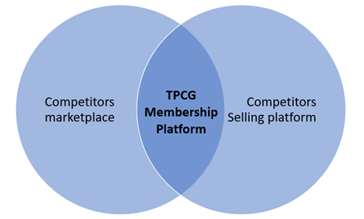
There are unofficial groups for selling or sharing game keys, for example, subreddits or discord servers that are community run environments. As they are unofficial, they aren’t properly moderated or secure. The merchant or purchaser in these community run groups are more susceptible to scams than users in an official environment, for example, you’re a lot more likely to get scammed from Facebook Marketplace than from Amazon.
Without an official platform for PC gamers to handle their unwanted or duplicate game keys, the introduction of a web application that allows users to buy, sell, trade, and share their game keys closes that gap in the market. Tayside PC Games are pioneering the very much needed change for PC gamers.Websites where you can buy individual game keys already exist, for example, “g2a” or “CD keys”, but they don’t have the option to sell their games. This is where TPCG comes in.
With the development of their new website that allows users to sell their unwanted game keys for in-site credits and use those credits to purchase previously sold game keys, members will turn their unwanted game keys into keys for games they want. With TPCG being at the forefront of the gap in the market ending, the group will see an increase in users joining the group to utilize the game key sharing platform and stay for the thriving community of 100+ like minded individuals. The increase of membership subscriptions will see TPCG with an increase in generated revenue, releasing the group from some of the financial pressures of running other systems, costs of events, etc., and allowing them to give back to the community. This website will put Tayside PC gamers on the map for all gamers who desire access to such a platform.

Aim
The fundamental aim of the TPCG project is to provide users with an environment to get rid of their unwanted game keys for an in-site currency and use those credits to purchase more desired game key titles. Of course, there are other secondary aims that are outside of Simple Coding Partners’ scope that are common to all companies or groups, such as growing the TPCG community and increasing the amount of generated revenue. The secondary aims will come indirectly through the success of the TPCG project aims. Common secondary aims not for the benefit of the TPCG management, but for the benefit of the members of the group. Aiming to provide TPCG with an increase in revenue and help to expand the community. With a larger reach and a bigger community, more members will take part in events and more users will socialize, with an increase in revenue – more money can be put towards, upgrading the current systems, and organizing more events, which in turn broadens the reach of the group and attracts new members. With the success of the primary aims, the secondary aims are also indirectly targeted.
At Simple Coding Partners (SCP) our aim is to create a web application that can encapsulate the personality of the community and provide the members with a place to essentially get rid of what they don’t want and gain what they do want.
Simple Coding Partners project aims:
- Design and develop a web-based application using PHP and MySQL for selling game keys.
- Develop a backend database that is fit to process large amounts of data.
- Impose fair use guidelines.
- GDPR Compliant site.
- User friendly and visually appealing UI.
The aims were achieved by utilizing a methodical approach. Firstly, we established project details and objectives. Building on top of that knowledge we were able to analyze the project and delegate tailored tasks to every member to effectively take advantage of their individual skill sets. We defined important project milestones, for example, implementation of the database or implementing the data from the database. This allowed us to keep track of what tasks were completed or in progress. We made use of a Kanban board to limit the tasks that were work-in-progress and maximize our efficiency.
The success of the SCP project will also help the aims of the Tayside PC games group. The group will see an increase in memberships and an increase in the generated revenue. With more funds there comes more opportunities.

Method

Method
- INTRODUCTION
Tayport PC Gamers or TPCG is a group consisting of computer based gamers who recently began work on a game activation key project. They asked us to create and manage the development of a website for sharing and selling game activation keys between members of their society. The objective of this was to streamline the usage of game keys and provide a modern solution to a common problem in unused game keys.
We set up the project to allow for immediate feedback on our website for the client to make sure we have clearly met the functional requirements and client needs. After considering this, we decided on using the evolutionary prototype methodology. This allowed for us to progress the website functionality based on feedback between those iterations. For example, we had the initial concept which was designed and implemented for the initial prototype before being refined and released.
- HOW WE SOLVED PROBLEMS
Evolutionary prototype methodology is a software development process that involves creating a prototype of the software and then refining it based on feedback from the client, as we touched on in the introduction. The process of this is incremental and involves a series of prototyping refinements.
The key selling website for a client can be developed using evolutionary prototype methodology. The process involves creating a prototype of the website and then refining it based on feedback from the client or end-users. This process can be repeated until the client considers it the final product.
An example of this process was completing the initial prototype frame of the website which included a brief layout of the features before showing that towards the client and checking for feedback and potential improvements based on their needs. After refining our website layout to specifications, the prototype was ready for use by the general public.
Evolutionary prototyping helped with solving common issues in web development such as knowing when it is necessary to stop tweaking the system and actually finish the development. For example, adding too many additional details to each game description which can make the layout less visually appealing and not to specifications set by the client. The interaction aspect of the interface however was eventually accepted and signed off.
- EVALUATION
There are several ways to evaluate and test KPI on a website for selling game activation keys. For example, the traffic source can be monitored. You can monitor metrics in Google Analytics such as traffic by source, sessions by socials, top keywords by sessions and how to quickly identify how people are finding your website. These are just some of the ways traffic can be monitored and evaluated on the website for TPCG activation keys. You can also evaluate KPI through cart abandonment rate - This KPI measures the percentage of visitors who add items to their cart but do not complete the purchase.
We tested the website through using the different functions which were set out in the client brief for us to create. Part of the testing period was making sure there was an effective login system with correct encryption to allow for compliance with data privacy laws. The client also asked for a working system in which you can buy or sell activation keys through a checkout system. We tested this thoroughly for bugs and made sure to stick to evolutionary prototyping methodology by refining through iterations suggested by the client at each stage of development.
- HOW OUR SITE WAS SET UP
To set up a website for activation keys in video games using evolutionary prototype methodology, there were several steps needed to be considered. Identifying the requirements for the website, Create a basic prototype of the website, Test the prototype with users and stakeholders, Gather feedback and use it to improve the prototype, Repeat steps 3 and 4 until the website meets all requirements.
We could also use tools such as WordPress or Wix to create the website. These platforms offer templates that you can customize to suit your needs. However, we decided on setting up the site using php, css and js as the main languages and hard coded the entire site to make sure it met the specifications of the client.
The first step was setting up our navigation system which was in the form of a navbar giving 'Home', 'About Us', 'Login' and 'Sign Up'. These figures were the main pages for our site. The homepage will focus on listing the game keys for ease of navigation while the login and sign up will be relating to account based protocols such as working with the database and accessing the game keys you've bought or sold. The about us section was a simple terms and conditions as well as privacy policy while also explaining to people what Tayside PC Gamers is.
We were asked to deliver mainly a service to buy and sell game keys. These were the main features needed within the functional requirements and high importance to delivering an effective prototype to the client.

- SUMMARY
In summary, we used the functional requirements given to us from the client, as well as the feedback received through our iterative use of the evolutionary prototype methodology. Through this, we created a successful website for selling activation keys for video games through a checkout system website for all members of the Tayport PC Gamers group to use and navigate. We completed this through use of high levels of documentation, refining the prototype and fine tuning it until it met the desires of the client within the timescale given.

Results

Results
The results of the project will be measured using the Quality Metrics put forth in the project proposal.
1. Site security
2. Site reliability
3. System usability
4. GDPR
5. System Accessibility

All figures can be found in Appendix A

Site Security
Firstly the site security has been implemented using standard security methods. Such as hashing user and admin passwords. As well as implementing prepared statements to protect user and website data from SQL injections and cross-site scripting. There are also protections in place to stop unregistered and non-logged-in users from assessing game Keys. However, as the project currently stands today there is a big security risk. As you can see by Figure 3.1.a the URL shows the Keys is shown in the web address. This is due to the fact that we had originally planned to encrypt the keys using our own encryption hence the key would still be secure. the other simpler option would be to change the https send method to get instead of post to hide the variable used. In order to test the security of the site it was run through ImmuniWeb a reputable online tool that searches the webpage and server the website runs on for vulnerabilities. The grade ImmuniWeb gave the project was a B (ImmuniWeb 2023). This was mainly due to the fact the website has not received any of its security certificates. One section of note however is the GDPR section of the report that found and recognised that the GDPR section of the footer included relevant info for the user. ImmuniWeb, however, cannot run a whole system scan so every public-facing form including forms on the admin page has the spaces and special characters of the entered data removed before being used in any part of the system. In this way the project has met its security requirements.

Site Reliability
Secondly, there is site reliability. The current project has been tested by having 5 continuous users and there were no issues found. This testing was conducted both during and after the development of the website. The results shown in this document (table below) are results taken at the end of development. The test was conducted by one member of the team at random intervals using a stopwatch to measure how long the page or action takes to load or complete focusing on the most used function. Such as Logging in, adding a new key, navigating between pages, and buying a key. This method is not accurate but must be done this way as it could not be done programmatically. As shown by the Table below the majority of loading times are less than half a second taking into account Human reaction time. Again, however, only 5 simultaneous users are well below the estimated 70+ concurrent users estimated in the proposal document. Hence further testing will be needed either before or after launch to ensure the system can handle the traffic running through it.
Test | Time 1 s | Time 2 s | Time 3 s | Time avg s
Navigation | 0.48 | 0.29 | 0.36 | 0.38
Login | 0.36 | 0.28 | 0.35 | 0.33
Add key | 0.55 | 0.48 | 0.51 | 0.51
Buy Key | 0.41 | 0.47 | 0.49 | 0.46

System usability
The next set of tests are on the website’s useability. This was tested by using a standard System Usability survey see Figure 3b, with 3 testers including the client. The test was performed twice. once at the start of the project using wireframes and again with the current version of the website. As you can see by the table below the results from the first round of testing ended with an average score of 82.5 which would equate to a very good website. However, as you can also see from the table below the client are the lowest score of the testers in round 1 of testing. So, we endeavour to improve this going forward with the project and we did somewhat. Sadly round 2 of testing could not be completed before this document’s publication. Due to the client being busy. However, if we average the gain from the other testers and apply it to the missing data, we will get a potential gain of 5 usability points. This would then give a final point value of 87.5 with is an equivalent grade of A. An excellent usable website. Raw data can be found in figure 3c.

Round | Tester 1 | Tester 2 | Tester 3  Client | Average score
1 | 90 | 87.5 | 70 | 82.5
2 | 97.5 | 90 | Estimated 75 | Estimated 87.5

GDPR
The next very important test that the project needed to pass is to pass GDPR laws on holding user data securely and informing users how to access or remove their data. this is important as if these laws are broken both we the developers and the client would be heavily fined as well as the loss of customer trust. With this in mind the security of the user’s data is secured with the methods previously mentioned. Also, by having the pictured information below in the footer of each webpage meets the requirements for informing the user their rights by GDPR is in accordance as well. To reaffirm these aspirations the website was tested using the aforementioned ImmuniWeb checker that highlighted that the GDPR policy was found and verified ImmuniWeb (2023). Another website was used to check that websites cookie use was up to GDPR code as well. This was the website cookiemetrix. Cookiemetrix confirmed that the website could be GDPR compliant and to seek further legal assistance to ensure compliance (cookiemetrix 2023).

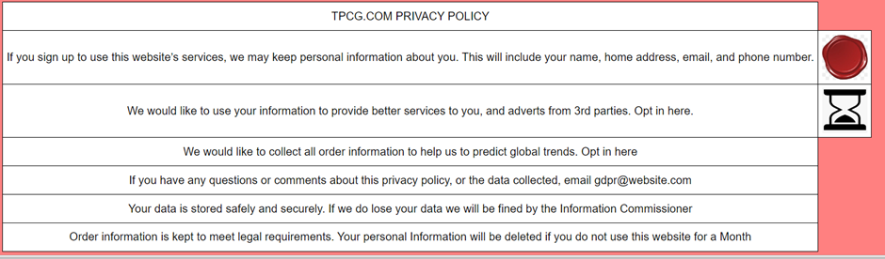
TPCG privacy policy

System Accessibility
Finally, Accessibility of the product. Tests for this topic are few due to the fact some of the advanced features have yet to be implemented such as colour-blind UI options. However, as the website currently stands all the website is machine readable to allow for readers to function. In order to do a properly tested up to a basic standard Wave was used. Wave is another online tool that takes a single webpage and scrubs thought its html/css and layout for basic breaches of accessibility. The report (Wave 2023) came back with one error and 7 alerts. The error was for the main banner of the webpage having no alt text which can be easily fixed in the next update. The alerts were for the links to the product pages being flagged as suspicious. There is not much to be done about this but as the creators of the website we know it to be safe. Additionally alternate test for the small symbols used in the footer were found and no problematic contrasts were found in the colour scheme, or the fonts used. Overall with one fix an excellent basic assessable website.

Word count: 1059

Discussion

General Discussion
It is difficult to categorically identify whether or not Simple Coding Partners (SCP) have been successful with this project. There are many aspects of this project that have been a great success, while in some areas SCP have been less successful. SCP have successfully created a website that allows logged in users to share game keys with each other, by allowing them to both give and take game keys. The website has also been established to have a high usability rating through the system usability scale as discussed in more detail in the results section. However, despite many successes, there are currently a couple of features not working that SCP have made their priority to fix. With these fixes or adjustments this website will be a full success with opportunity for future improvement to make it even better.
The website allows a user with an account to log in using their username and password that is stored securely in the backend database. Once logged in there are many different actions that a user is able to carry out. If the user has a spare game key that they don’t want, they can input the details of it, allowing someone else to take it. The user is also able to pick from the selection of games available on the website and then take the key for a game should they decide they want it. When a user takes a game key, that game is then removed from the database so no one else can access it. There is also an admin page where leaders or founding members (whoever you give admin role to) will be able to control most features on the website, however this control should in the vast majority of cases not be necessary but is provided in case it is wanted or needed. All this points towards this project being a success from SCP.

Conclusions
In conclusion, the accomplishment of this project finally gives you, Tayside PC gamers (TCPG), your very own platform, a space where it’s easy for you to trade your game keys without the need for lengthy discussions on swap deals or having to wait to find someone who wants your spare game key. This website also gives you the scope to grow a lot as a community as more people want to trade game keys from further afield, you will now be able to trade game keys with people in different time zones, should they wish to join the fun, now that you no longer need to be awake to talk to the person who wants your game key.
As well as all this, once some of the future work is complete, you TCPG will be able to charge a small membership fee for access to the website, this would allow you to make a small amount of money that you can then invest back into TCPG in the future.
Should you want to branch out further in the future, this website can be the foundation of any future ideas or developments for the group, this isn’t just a website, it’s a platform for you to build upon in the future as you develop. But this website isn’t just about the future, it’s also about the here and now, this is an opportunity for you to take TPCG beyond being a discord server, reducing the work for your moderators, making the group easier to manage as it expands, and giving you a shiny new platform to trade your game keys.

Future Work or Countermeasures
As stated earlier, there are currently two features on the website that don’t work. There are the sign-up form and the credit system. SCP have made these two features their first priority to fix. This would mean members would then be able to sign up directly through the website without any need to get an admin involved. Fixing the credit system would mean that users would be limited in the number of game keys they can take as they would need to buy them with credits, and this would give an incentive to trade in game keys as that is how you get more credits.
Once those two broken features have been fixed SCP would turn their attention to implementing a series of features that would improve the finished project. The first and by far most notable of these would be a mechanism to automatically set the buy and sell prices (in credits) for any game that a user sells the website, based on that game’s actual value in real money. This would account for the fact that different games are worth different amounts while still giving the user credits straight away when they sell a game to the system. To be able to achieve this the system would need to be able to look up the price of a game on various different platforms like steam. From that price it could then run a formula to give a number of credits to give the user who traded in the game and to sell it on for.
There are also two other features SCP would like to add to the project in the future, the first of these is simply a list of games that the logged in user has traded in, shown on the user page when they log in. The second and more significant of the two, would be a payment system attached to the sign up form. This would mean that those signing up to the site would be asked to pay a small membership fee to find TCPG and the upkeep of the site.

Call to action
Alongside the website, yes SCP don’t just build something and tell you to get on with it, you TCPG will be offered a short two-hour session with one of the SCP’s developers who worked on this project. They will show a group of your founders how to use the site, and the admin page, as well as explaining how to get access to the database itself should you ever need it. This will mean that your admin users will know how to work the system.
To contact us please use simplecp@simplecp.co.uk
Or alternatively you can phone us on 01382 43227

Word count: 1047

References
Taylor Hall 2002415 References
Govil, N., Saurakhia, M., Agnihotri, P., Shukla, S. and Agarwal, S. (2020). Analyzing the Behaviour of Applying Agile Methodologies amp; DevOps Culture in e-Commerce Web Application. [online] IEEE Xplore. doi:https://doi.org/10.1109/ICOEI48184.2020.9142895.
Molina-Ríos, J. and Pedreira-Souto, N. (2020). Comparison of development methodologies in web applications. Information and Software Technology, 119, p.106238. doi:https://doi.org/10.1016/j.infsof.2019.106238.
Rastogi, A. (2018). Top 8 Tips and Tricks to Achieve Project Goals. [online] Project-Management.com. Available at: https://project-management.com/top-8-tips-and-tricks-to-achieve-project-goals/.
Torrecilla-Salinas, C.J., Sedeño, J., Escalona, M.J. and Mejías, M. (2015). Estimating, planning and managing Agile Web development projects under a value-based perspective. Information and Software Technology, 61, pp.124–144. doi:https://doi.org/10.1016/j.infsof.2015.01.006.

Connor Murphy 1903299
ImmuniWeb(2023). AI for Application security. Available at: https://www.immuniweb.com/websec/mayar.abertay.ac.uk/wk4hTDN5/.(accessed 27 April 2023)Entered URL https://mayar.abertay.ac.uk/~cmp311g22c04/simpleCP/View/user.php

cookiemetrix (2023). Determines if your website is not comply with EU Cookie Law. Available at: https://www.cookiemetrix.com/display-report/mayar.abertay.ac.uk/91483b47fda71e6041f1289d6cdab525 (accessed 27 April 2023)
Entered URL https://mayar.abertay.ac.uk/~cmp311g22c04/simpleCP/View/index.php

usability.gov (2019). System Usability Scale (SUS). [online] Usability.gov. Available at: https://www.usability.gov/how-to-and-tools/methods/system-usability-scale.html. (accessed 27 April 2023)
Wave(2023). Web accessibility evaluation tool Available at: https://wave.webaim.org/report#/https://mayar.abertay.ac.uk/~cmp311g22c04/simpleCP/View/index.php (accessed 27 April 2023)
Entered URL https://mayar.abertay.ac.uk/~cmp311g22c04/simpleCP/View/index.php

Appendices

Appendix A - Results raw data
Figure 3.1.a

figure 3.1.b
System Usability Scale (John Brooke: SUS – A quick and dirty usability scale).

Disagree agree
1.I think that I would like to use this system frequently 1 2 3 4 5
2.I found the system unnecessarily complex 1 2 3 4 5
3.I thought the system was easy to use 1 2 3 4 5
4.I think that I would need the support of a technical person to be able to use this system 1 2 3 4 5
5.I found the various functions in this system were well integrated
1 2 3 4 5
6.I thought there was too much inconsistency in this system
1 2 3 4 5
7.I would imagine that most people would learn to use this system very quickly
1 2 3 4 5
8.I found the system very cumbersome to use 1 2 3 4 5
9.I felt very confident using the system 1 2 3 4 5
10.I needed to learn a lot of things beforeI could get going with this system
1 2 3 4 5

Home page
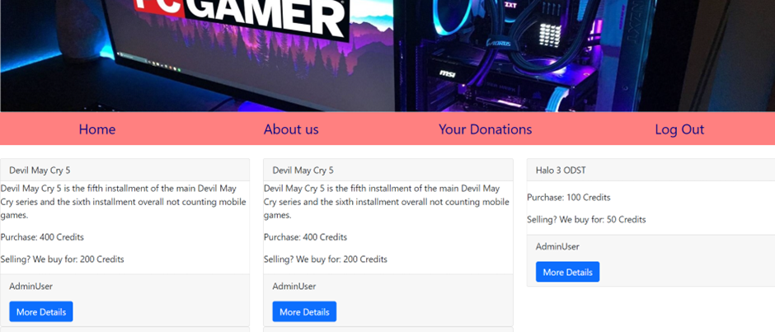
User page
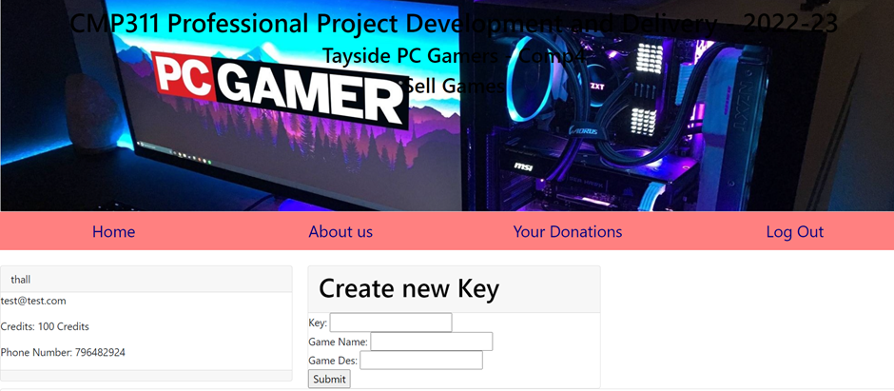
3.1.c raw sus results
SUS survey results round 1

SUS scores have a range of 0 to 100.
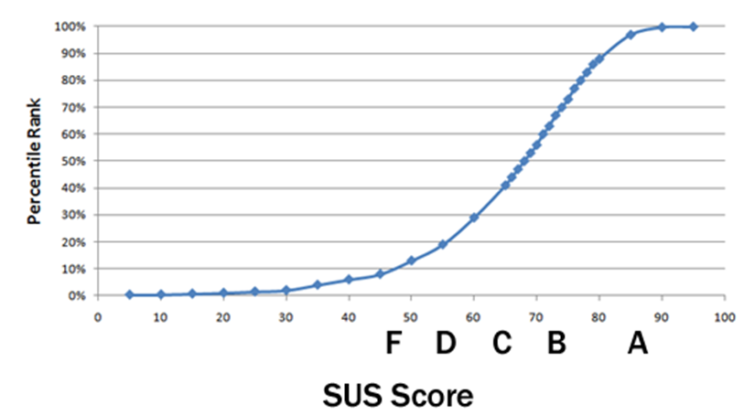

Tester 1
Sus converted score 7.5 + 7.5 + 10 + 10 + 7.5 + 10 + 10 + 10 + 7.5 + 10 = 90
Following that the agreed upon average is 64 and following the grading curve above the final result is an A+
Disagree/Agree
1. I think that I would like to use this system frequently 1 2 3 4 5
2. I found the system unnecessarily complex 1 2 3 4 5
3. I thought the system was easy to use 1 2 3 4 5
4. I think that I would need the support of a technical person to be able to use this system 1 2 3 4 5
5. I found the various functions in this system were well integrated
1 2 3 4 5
6. I thought there was too much inconsistency in this system 1 2 3 4 5
7. I would imagine that most people would learn to use this system very quickly
1 2 3 4 5
8. I found the system very cumbersome to use 1 2 3 4 5
9. I felt very confident using the system 1 2 3 4 5
10. I needed to learn a lot of things before I could get going with this system
1 2 3 4 5

Tester 2
Sus converted score 5 + 10 + 10 + 10 + 5 + 10 + 10 + 7.5 + 10 + 10 = 87.5
Following that the agreed upon average is 64 and following the grading curve above the final result is an A
Disagree/Agree
1. I think that I would like to use this system frequently 1 2 3 4 5
2. I found the system unnecessarily complex 1 2 3 4 5
3. I thought the system was easy to use 1 2 3 4 5
4. I think that I would need the support of a technical person to be able to use this system 1 2 3 4 5
5. I found the various functions in this system were well integrated
1 2 3 4 5
6. I thought there was too much inconsistency in this system 1 2 3 4 5
7. I would imagine that most people would learn to use this system very quickly
1 2 3 4 5
8. I found the system very cumbersome to use 1 2 3 4 5
9. I felt very confident using the system 1 2 3 4 5
10. I needed to learn a lot of things before I could get going with this system
1 2 3 4 5

Tester 3
SUS Score converted 5 + 10 + 7.5 + 5 + 5 + 5 + 7.5 + 5 + 10 + 10 = 70
Following that the agreed upon average is 64 and following the grading curve above the final result is an B
Disagree/Agree
1. I think that I would like to use this system frequently 1 2 3 4 5
2. I found the system unnecessarily complex 1 2 3 4 5
3. I thought the system was easy to use 1 2 3 4 5
4. I think that I would need the support of a technical person to be able to use this system 1 2 3 4 5
5. I found the various functions in this system were well integrated
1 2 3 4 5
6. I thought there was too much inconsistency in this system 1 2 3 4 5
7. I would imagine that most people would learn to use this system very quickly
1 2 3 4 5
8. I found the system very cumbersome to use 1 2 3 4 5
9. I felt very confident using the system 1 2 3 4 5
10. I needed to learn a lot of things before I could get going with this system
1 2 3 4 5

SUS survey results round 2
Tester 1
Sus converted score 10 + 10 + 10 + 10 + 10 + 10 + 10 + 7.5 + 10 + 10 = 97.5
Following that the agreed upon average is 64 and following the grading curve above the final result is an A+
Disagree/Agree
1. I think that I would like to use this system frequently 1 2 3 4 5
2. I found the system unnecessarily complex 1 2 3 4 5
3. I thought the system was easy to use 1 2 3 4 5
4. I think that I would need the support of a technical person to be able to use this system 1 2 3 4 5
5. I found the various functions in this system were well integrated
1 2 3 4 5
6. I thought there was too much inconsistency in this system 1 2 3 4 5
7. I would imagine that most people would learn to use this system very quickly
1 2 3 4 5
8. I found the system very cumbersome to use 1 2 3 4 5
9. I felt very confident using the system 1 2 3 4 5
10. I needed to learn a lot of things before I could get going with this system
1 2 3 4 5

Tester 2
Sus converted score 7.5 + 10 + 10 + 10 + 7.5 + 10 + 7.5 + 10 + 7.5 + 10 = 90
Following that the agreed upon average is 64 and following the grading curve above the final result is an A+
Disagree/Agree
1. I think that I would like to use this system frequently 1 2 3 4 5
2. I found the system unnecessarily complex 1 2 3 4 5
3. I thought the system was easy to use 1 2 3 4 5
4. I think that I would need the support of a technical person to be able to use this system 1 2 3 4 5
5. I found the various functions in this system were well integrated
1 2 3 4 5
6. I thought there was too much inconsistency in this system 1 2 3 4 5
7. I would imagine that most people would learn to use this system very quickly
1 2 3 4 5
8. I found the system very cumbersome to use 1 2 3 4 5
9. I felt very confident using the system 1 2 3 4 5
10. I needed to learn a lot of things before I could get going with this system
1 2 3 4 5

Tester 3 not completed
Sus converted score + + + + + + + + + =
Following that the agreed upon average is 64 and following the grading curve above the final result is an

Appendix B - Deliverables & requirements (Required)

Agreement Form: Project Deliverables
Group Name, Names of Team Members, and Program | Simple coding partners  Ben Gilmour  Connor Murphy  Duncan Kelly  Ross Jackson  Taylor Hall  TPCG Project
Subject specialist’s Name (Client) | DR Lynsay Shepherd  DR Shailendra Rathore
The deliverables listed below will be submitted by the team by the due date.

Part A deliverables | Source code
- Requirements Specification, signed off by the program specialist.
- Testing records
- Initial prototype

Subject specialist’s (Client) signature | Dr Lynsay Shepherd  Dr Shailendra Rathore
Team members’ signatures | Cmurphy , Duncan Kelly, Ben Gilmour, R Ross Jackson  Taylor Hall

Agreement Form: Requirements

Group Name: The Simple Coding Partners
Team members (print): Ben Gilmour, Connor Murphy, Duncan Kelly, Harry Paremain, Ross Jackson, Taylor Hall
Project Title: Tayside PC Gamers AKA TPCG

Please refer to the attached documentation for full details on the project. The requirements are listed in Table 1. The signatures below indicate that the requirements for this project have been agreed by the project stakeholders.

Any changes to the project documentation should be made using the correct change authorization procedure agreed with the program specialist.

Table 1
ID | List of Agreed Requirements (fill in)
f1  f2  f3  f4  f5  nf1  nf2  nf3  nf4  nf5 | Members must be able to share unused game activation keys between each other.  Members should be able to donate any spare keys.  Members can claim keys for desired games.  Keys must only be shown to an owner of the claimed key.  Keys must be removed from circulation once claimed.  Fair use limits must be imposed.  The site must differentiate between different game platforms.  The site must display correctly on mobile screens.  The system must allow founding members to override fair use limits.  The user’s private info will be held following the GDPR guidelines.

Stakeholders | Signatures | Date
Team members  Ben Gilmour  Connor Murphy  Duncan Kelly  Ross Jackson  Taylor Hall | Ben Gilmour  Cmurphy  Duncan Kelly  Ross Jackson  Taylor Hall | 09/02/23  02/02/23  02/02/23  09/02/23  09/02/23
Subject Specialist  Lynsay Shepheard  Shailendra Rathore |  | 17/02/23
Client (if applicable) | N/A

